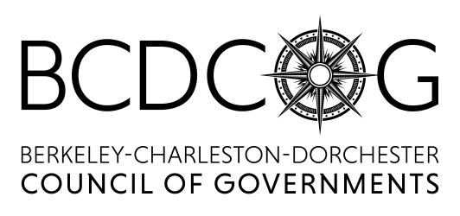

Mobility Management Outreach/Certification Specialist Full-Time Opportunity:

The Berkeley-Charleston-Dorchester Council of Governments' primary objectives are to assist local governments develop local and regional plans within the tri-county region, as well as providing local governments with planning and technical support to improve the quality of life in the region, which is located on the coast of South Carolina and has a population of over 775,000. The Charleston area is known for beautiful beaches, golf courses, award winning restaurants, arts and entertainment.

Because of an attractive quality of life and increased economic opportunities, the region has experienced a positive growth rate which requires new ideas and programs to improve traffic and accommodate future growth. We are looking for a Mobility Management Outreach/Certification Specialist who will be responsible for human service coordination, ADA certification for paratransit services, transit agencies Adopt-A-Stop Program and Commerce Program.

You would be a good fit for this position if you are interested in the following essential functions:
- Assist with the development and maintenance of a plan for human services transportation by collaborating with community organizations that provide such services in Berkeley, Charleston, and Dorchester counties to:
1. Research needs and demands of users;
2. Review regulatory processes;
3. Facilitate communication between agencies; and
4. Develop incentives to encourage agency participation as needed.
- Responsible for reviewing paratransit ADA certification applications to determine eligibility for service under the CARTA tele-a-ride program. Assist ineligible customers in identifying other means of transportation which might meet their needs. Build relationships with other community resources to assist applicant with their specific needs. Establish and maintain contact list of community resources.
- Acknowledge application for para-transit service timely.
- Explain ADA certification process and how long it should take to receive a response to the applicant.
- Provide outcome of application and
  - When approved explain the benefits of the paratransit program.
  - When applications are not approved offer alternatives for para-transit program.
- File and maintain all records relative to para-transit services and provide reports as needed.
- Strengthen the network of human services transportation providers in Berkeley, Charleston, and Dorchester counties while maintaining and supporting the identity of each provider in order to provide increased mobility in the region. Coordinate with senior centers, libraries, etc. to ensure information regarding available resources is available at their locations.
- Promote transit agencies Adopt-A-Stop program by registering businesses for the program and providing guidance and administration for the program.
- Coordinate regional transportation providers’ compliance with the Americans with Disability Act (ADA) and other federal and state laws and regulations pertaining to persons with disabilities. Review applications to determine eligibility. File and maintains compliance records.
- Promote and provide information to businesses on the transit agencies Commerce Program. Register businesses and provide support and guidance as needed. Work with the marketing team on promoting the Program and businesses on social media and at events.
- Proficient in Microsoft Office Suite to include Outlook, Word, Excel and PowerPoint.

Additional Duties:
- Participate in events and meetings as needed which may require attendance after normal business hours.
- Performs other duties as required by the Marketing Coordinator, Deputy Director of Operations and Support, Executive Director or designee.

We would like to hear from you if you have the following background:
- Bachelor’s Degree in business administration, or other related field with emphasis in journalism, communications or marketing preferred and one year of relevant job experience and strong writing skills.
- Excellent verbal and written communication skills, strong organizational skills and the ability to work well with all levels of internal staff, organizational boards, and the general public.
- Must be enthusiastic and foster genuine interest in assisting the public of the BCD region with their transportation needs with excellent follow up skills in order to build relationships.
- Comfortable with making presentation to small and large audiences.
- Ability to establish and maintain priorities in order to complete assignments by deadlines with minimum supervision.
- Valid Driver’s License or the ability to obtain one.

Applications are now being accepted at our Main Office or you can email/fax resume to:
BCD Council of Governments
Attention: Star Ross
5790 Casper Padgett Way
North Charleston, SC 29406

Fax resume to:
(843) 529-0305

Email to:
starr@bcdcog.com

EOE

